WordPress - Media Setting

In this chapter, we will study about Media Settings in WordPress. It is used to set the height and width of the images which you're going to use on your website.
Step (1) − Click on Settings → Media option in WordPress.
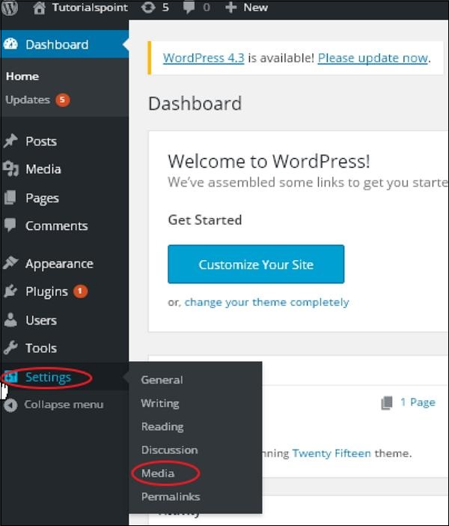

Step (2) − The Media Settings page is displayed as seen in the following screenshot.
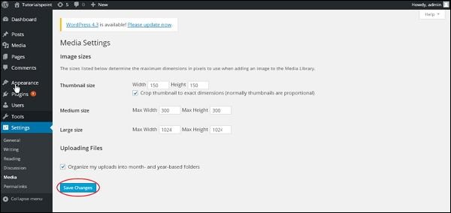
Following are the details of the fields on Media settings −
- Thumbnail size − Set the size of the thumbnail.
- Medium size − Set the height and width of medium size images.
- Large size − Set width and height of larger images.
- Uploading files − After checking this checkbox, the uploaded image will be arranged into year and month based folder.
Step (3) − After setting the dimension in pixels, click on Save Changes button. It saves your media setting information.

